

DEPARTMENT OF INFORMATION TECHNOLOGY
SCHOOL OF INFORMATICS
LOGBOOK:MOBILE APPLICATION DEVELOPMENT
UNIT CODE :BIT 4107
BY:
NAME:ABDIHAMID ABASS
REGNO:BIT/2024/43274
PROJECT NAME:STUDENT APP PROJECT

Contents
WEEK 1: 3
WEEK 2: 6
WEEK 3: 8
WEEK 4: 10
WEEK 5: 11

WEEK 1:

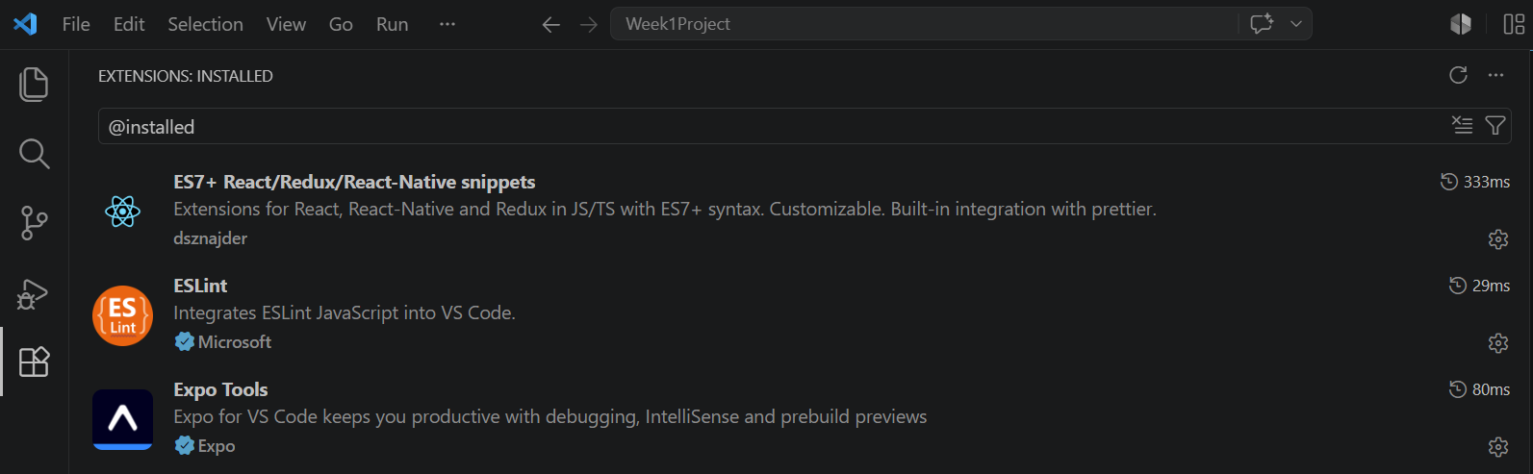figure 1.1 Successful installation of extensions in vs code

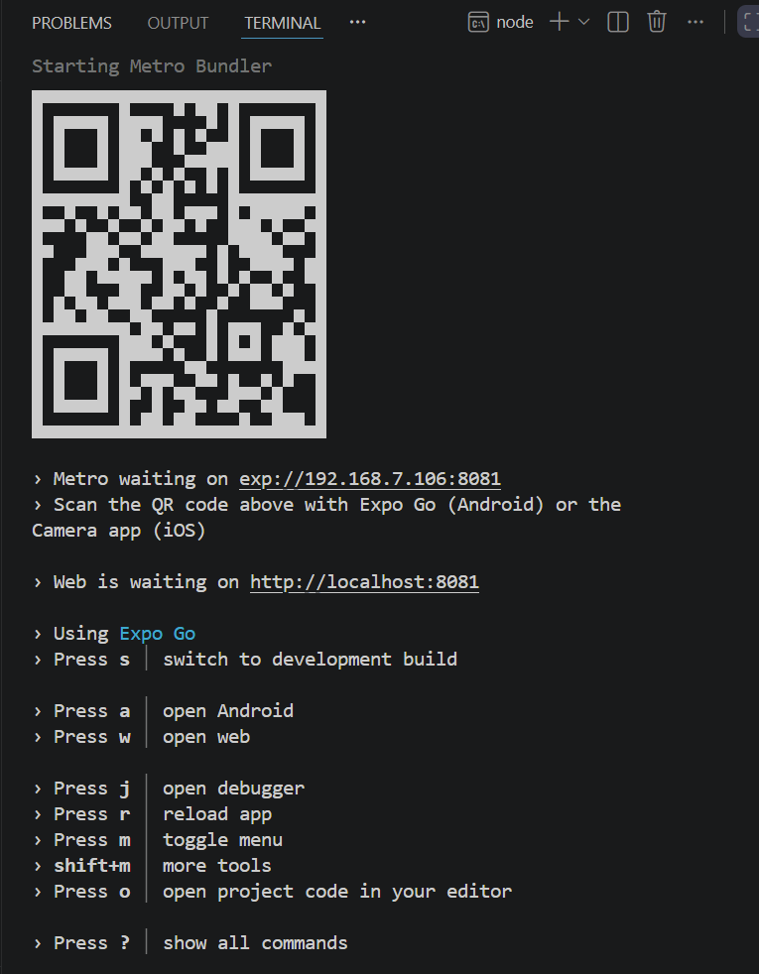

Figure 1.2:QR code linking the project to mobile phone

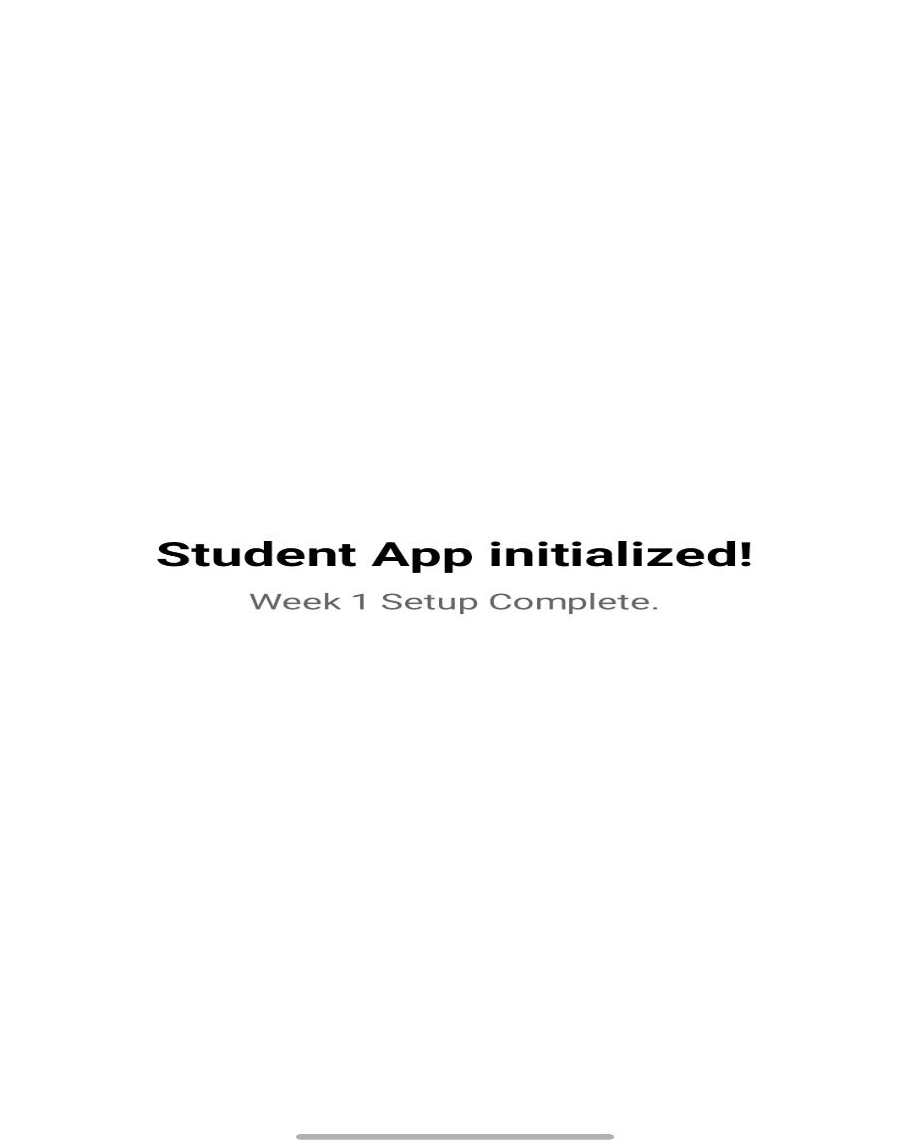

Figure 1.3:successful app initialization

WEEK 2:
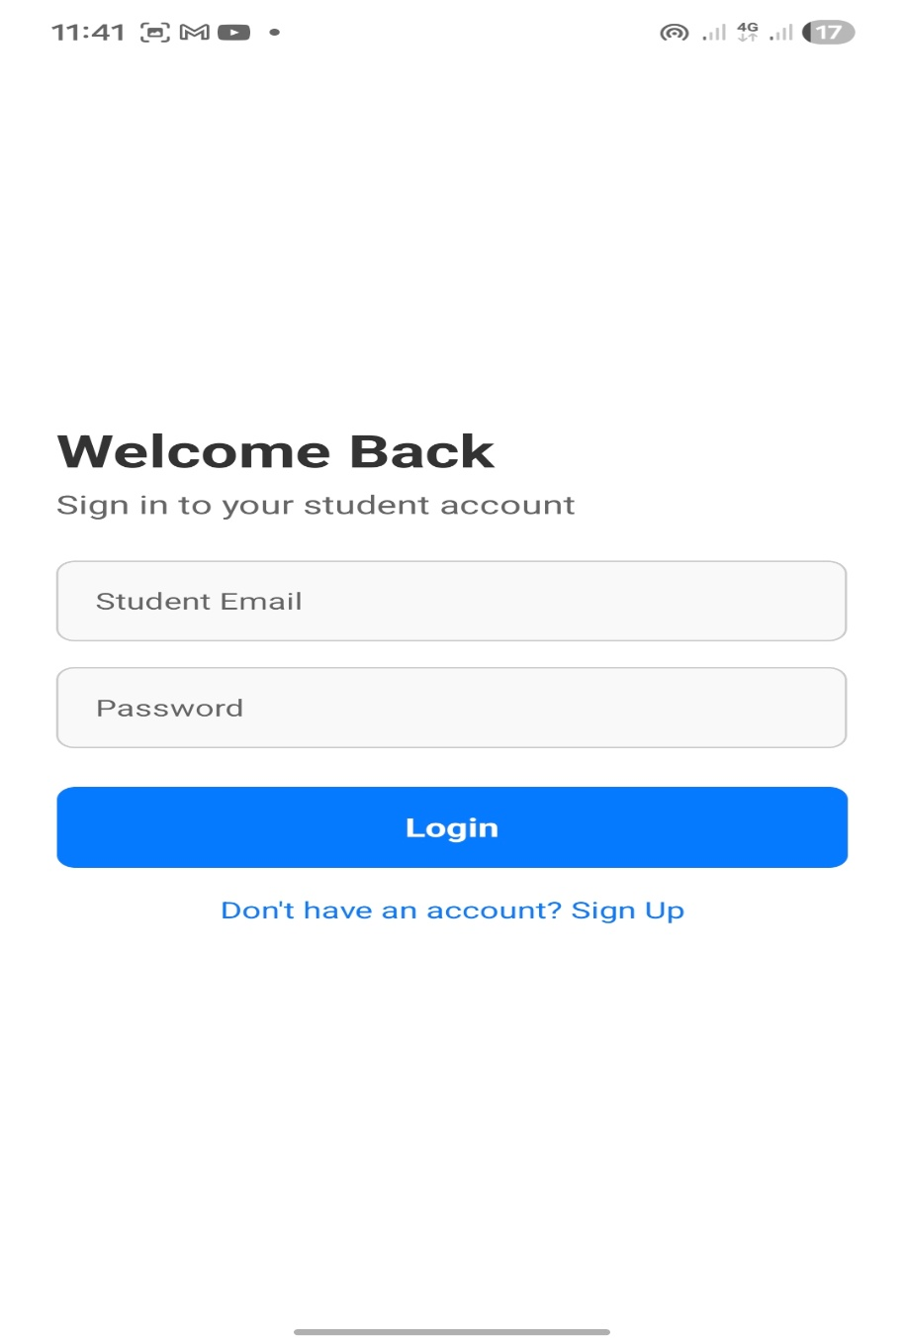

Figure 2.1:live physical mobile device testing veiw for login inside expo

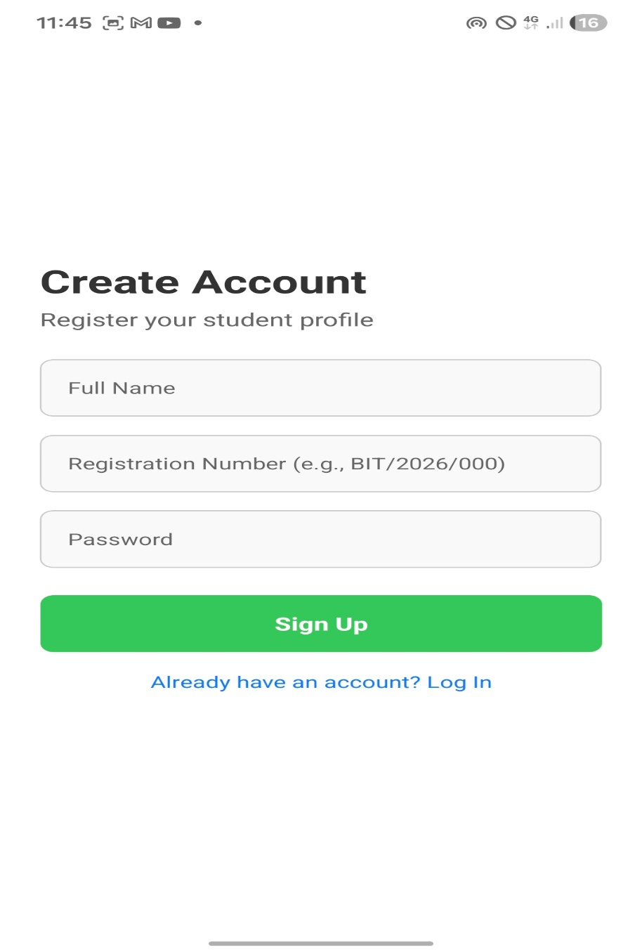

Figure 2.2:sign up page

WEEK 3:
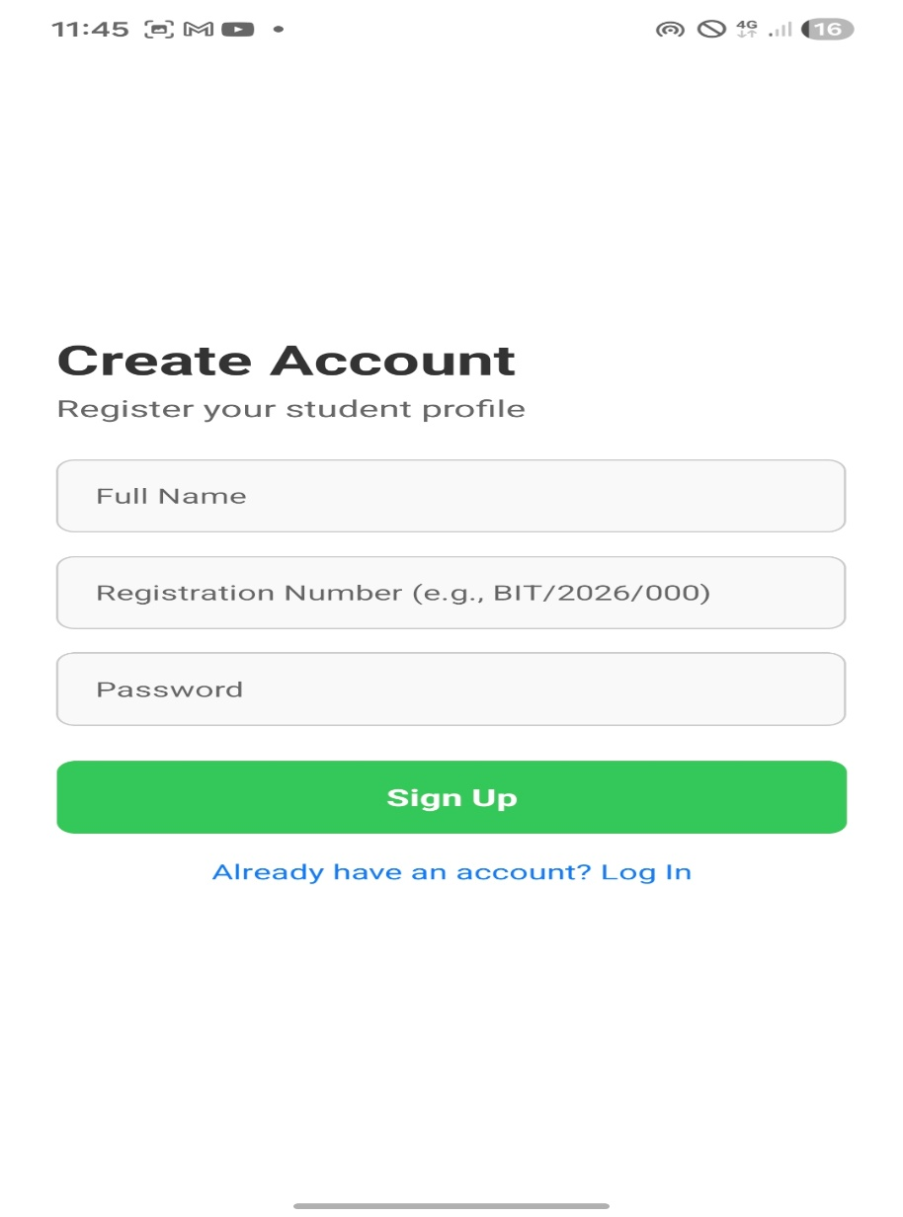

Figure3.1: an interractive UI with both sign up and login buttons

WEEK 4:
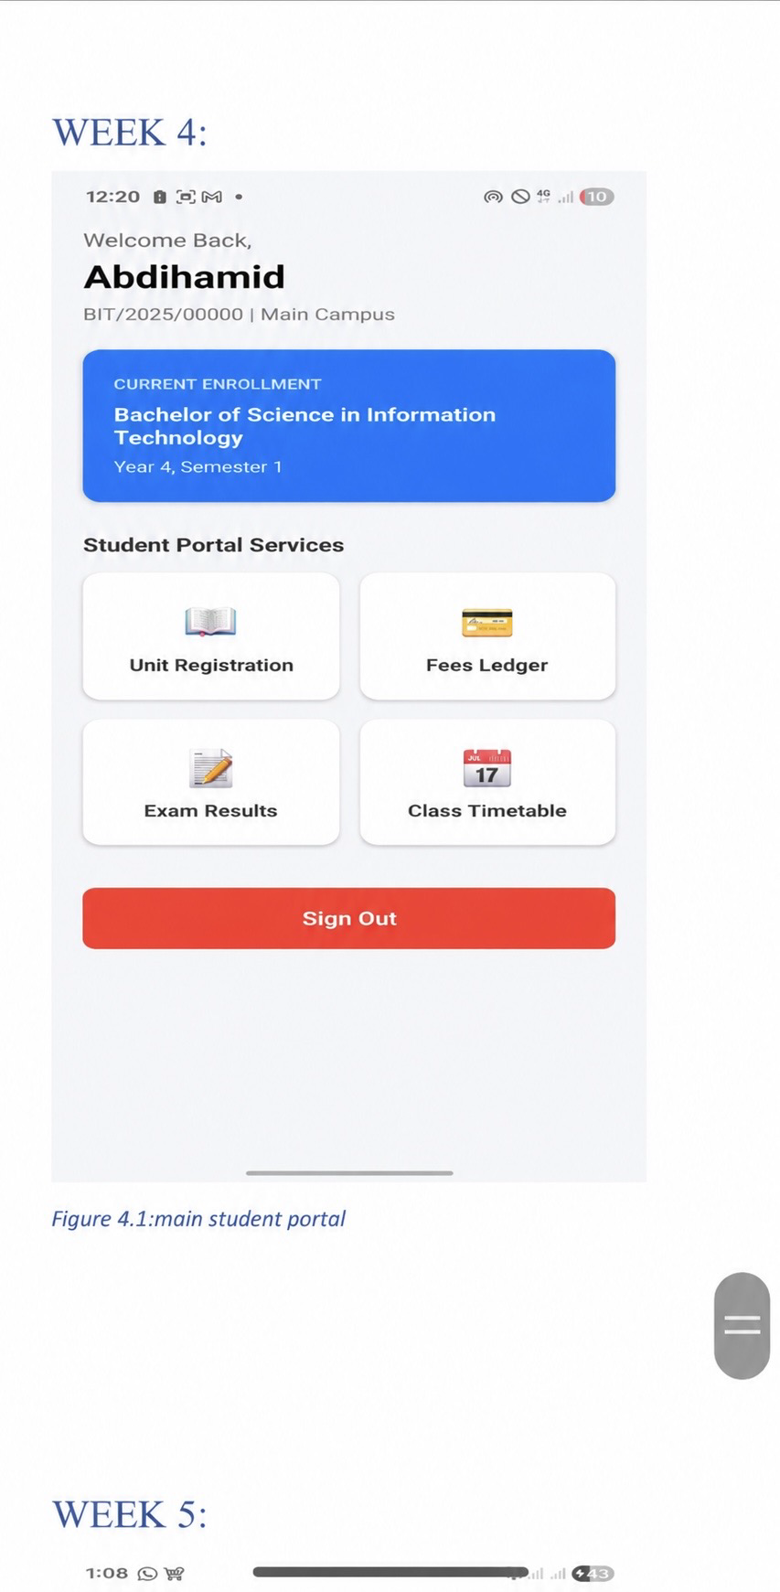

Figure 4.1:main student portal

WEEK 5:
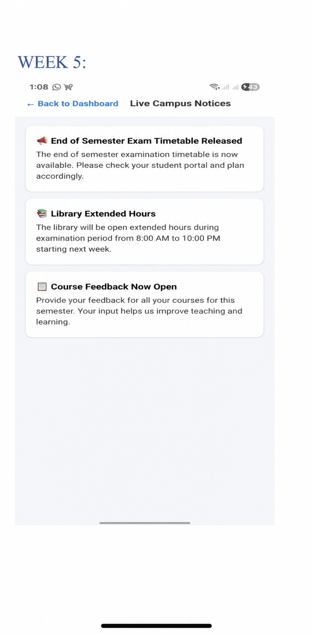

Figure 5.1:dynamic announcements layout driven by backend GET API

https://github.com/ABDIHAMID8/mobile-dev-student-mini-app.git

